So there is antoher factor i.e. Core point which means if for any point p it has more that or equal number of minimum number of Minpts in Eps radius so it said to be a Core Point.

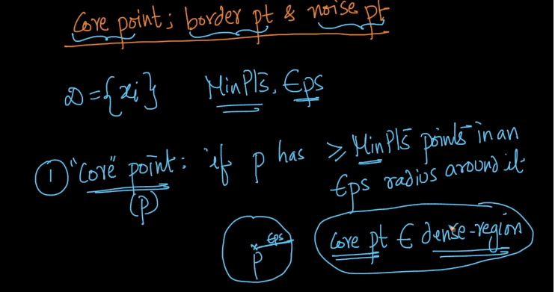

Another point i.e. Border point has two conditions.

So for a point which has less that Minpt in EPS radius around it but it is neighbourhood of other core point is Border point.

So Neighbourhood here means the point should be in range of EPS from another core point.

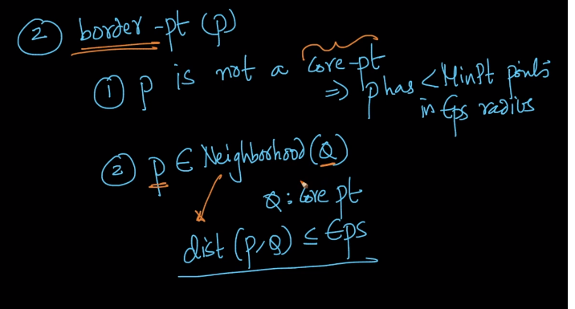

Taking below example:

Here P1 is core point because it has more than Mnpts in range Eps and P2 is border point because it has less that Mnpts in range Eps but it is neighbour of point P1(i.e. P1 is at distance less than EPS from P1)) which is a core point. Point P3 is Noise Point because it is neither Core nor Border point.

NOTE: to calculate core point or border we consider the point itself too and so if p2 has 4 points in radius including p2 itself so we say it core point and not border point or else we will say it border point.

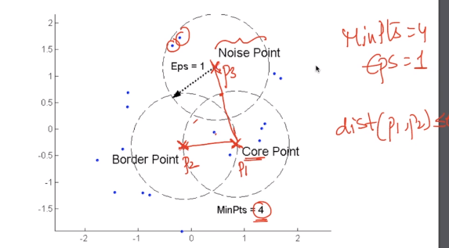

If we see below image all the green points or dense points are core points whereas the points near to it are Border points and red points are noise points.

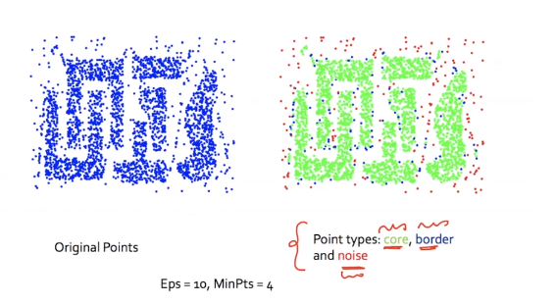

**Comments:**



